Sponsorship prospectus


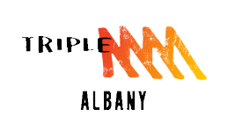
Great Southern Street Machine Assoc.Inc

29th Annual

2025

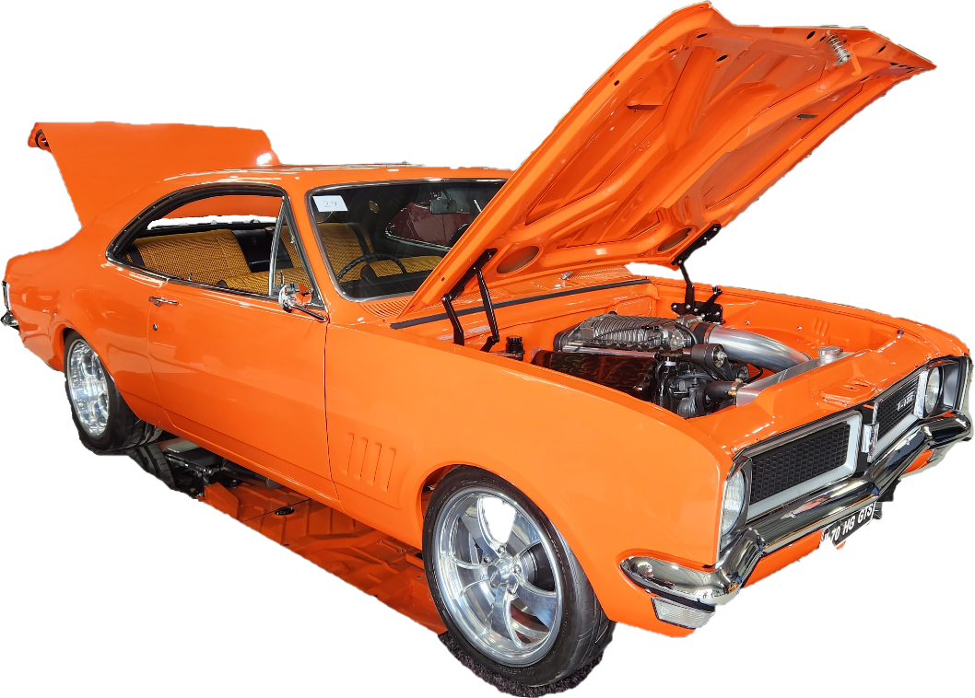

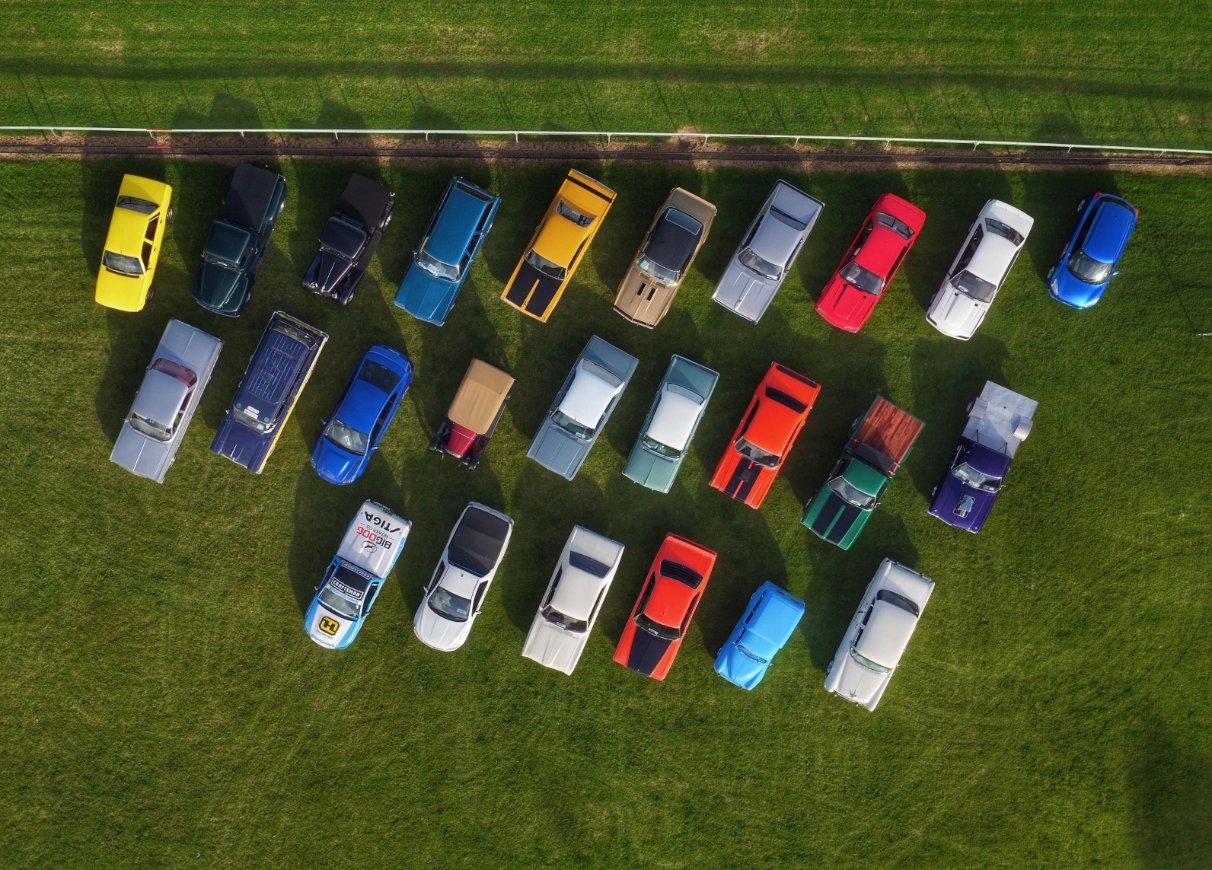
Contents

1/ Our Club………………………………………………………………………. 4

2/ Event Overview………………………………………………………………. 6

3/ Our Reach……………………………………………………………………… 8

4/ Why sponsor GSSMA Inc. Show & Shine……………………………… 10

5/Sponsorship Packages……………………………………………………… 12

6/ Sponsorship Benefits……………………………………………………….. 14

7/ Confirmation of Sponsorship……………………………………………… 17

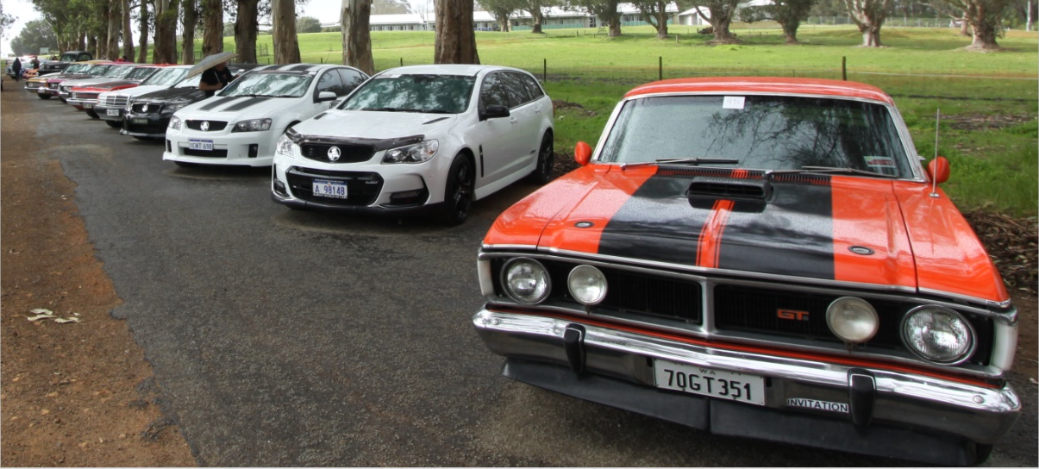

The Club
Our Club:

The Great Southern Street Machine Association Inc is a not-for-profit sporting club for anyone with a passion for all things automotive. The club was founded over 40 years ago and has been active within the community since inception.
We have a very diverse membership which numbers more than a hundred. We have monthly meetings as well as numerous automotive activities throughout the year for members or any interested parties.
The Club organises grass roots motorsport events throughout the year examples of events we conduct are Motorsport Australia speed event Series Wind Farm Hill Climb and Pendeen Sprint, Gnowangerup Roll Racing, Nyabing Drift and Motorkhana. The Club travels extensively throughout the region assisting other Clubs to conduct motorsport events.
The motorsport events the Club facilitates require our members to officiate at the event. We are able to provide officials as the club has a strategic plan that encourages members to participate in training courses approved/conducted by Motorsport Australia. This is an ongoing plan; and we hold several Motorsport Australia training courses throughout the year. The practical training is via events we conduct, and events held by other sporting associations.
We are highly active in the local community, supporting local motoring events, such as Albany Classic-Around the houses, TARGA West, Tarmac Rally and Rally Sport Events, VCCC Easter Display, Cars & Coffee, Albany Cars on the Green, Museum display, Operation Rudolf, City of Albany Christmas pageant. We also have our annual Christmas lights Cruise opened to the public to come along and enjoy the Christmas Lights. The Club also provides displays, event volunteers, officials, entrants, and spectators. The Club is a big supporter of local charities.
Our annual Show & Shine is the high light of the year for the community and our Club. It has been running successfully and continually for the past 29 years and each year it continues to grow and go from strength to strength.
From humble beginnings we have now progressed to be fully indoor event, one of only a few indoor car shows within the State. Our event is spread over a large pavilion and surrounding ovals there is plenty to see and do for the whole family.

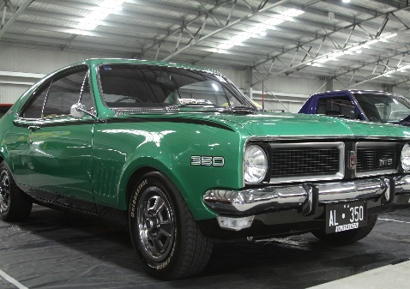
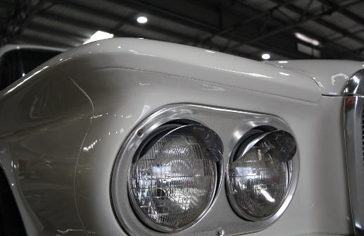
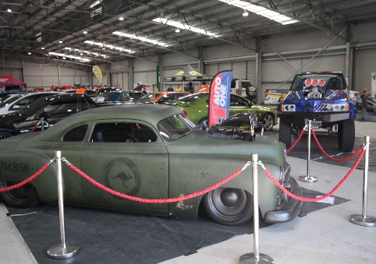

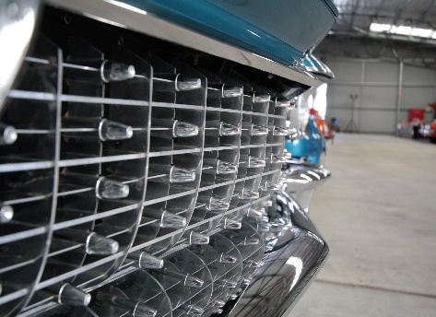
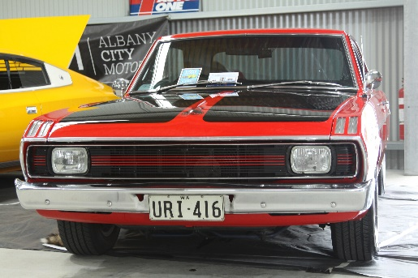
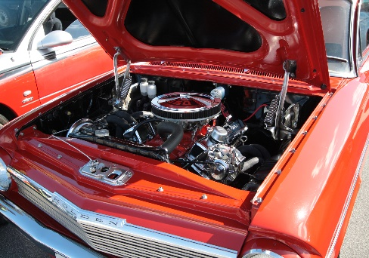

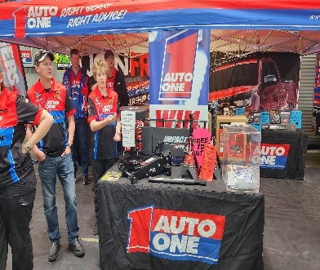
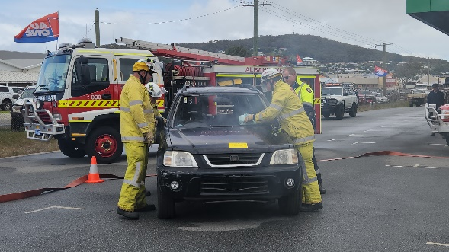
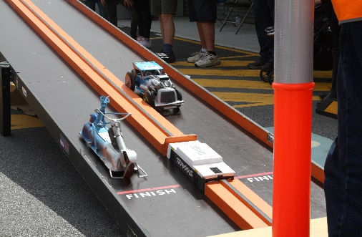

Event Overview

The Event:

The Annual GSSMA Triple M Albany Show & Shine 2025, providing a full car culture experience to compliment a three-day jammed packed programme that includes more than just horsepower. Held over the September long weekend, the varied line-up of activities includes Cars & Cocktails, the only indoor Show & Shine in the Great southern, Cars from all eras, all makes and models on static display, the annual Super Cruise/ Poker Run, the much-anticipated Rocker Cover Races, culinary delights, music, trade/market stalls, entertainment for the kids, ensuring all attendees enjoy this event.

This is an excellent opportunity to be involved with this iconic community event and to show case what Albany has to offer to the many visitors.

Day 1 Friday 26th September
Cars & Cocktails evening

Day 2 Saturday 27th September
Super Cruise/ Poker Run: Play poker as you cruise with car and bike enthusiasts, see the sights of Albany, enjoy a cruise with fellow Show & Shine entrants.

Photo Shoot: Opportunity for a group photo for those entrants who come along on the Super cruise/Poker run.

Day 3 Sunday 28th Sept Centennial Pavilion

Guest Display
Each year we invite high end vehicle to be our prominent display.

Show & Shine Car Display
Promising a great social event for all members of the family, the Show & Shine is opened to the public and the exhibition of dozens of exciting Street Vehicles will be accompanied by plenty of family friendly activities with lots of things to see and do.

Judging: Attention to detail and effort by the Vehicles proud Owners will be rewarded. In addition to the coveted Best of Show trophy, there will be Top Ten trophies for cars, various category trophies for bikes, and people’s choice trophy.

Rocker Cover Races: For young and old, transform a Rocker Cover into a race car. Pit it against other rocker racers. Trophy for the fastest on the day, Runner up and best presented Racer. Free to enter for all ages, one per person.

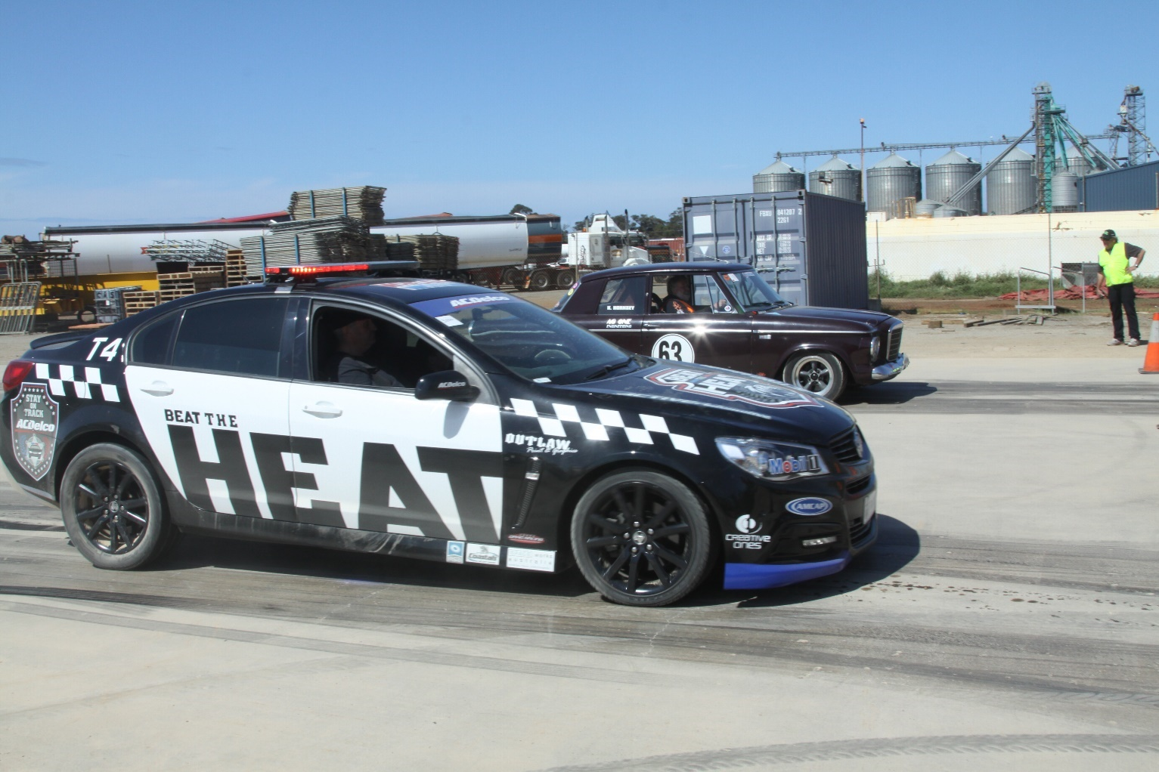

Our Reach

Digital Audiences:

GSSMA Inc. Albany Show & Shine 2025 utilises a full range of digital channels to ensure that our stakeholders have access to all the latest news and information regarding the event. These channels allow us to interact with our audience in real time and has led to some fun interactions. As a sponsor we will incorporate your branding and marketing messages into our digital content in a way that our audience will find engaging (frequency depends on package).

Social media channels Other Digital Channels




Facebook Instagram Website email

Listnr app industry event pages

Event Media Exposure:

GSSMA Inc. Albany Show & Shine 2025 also invests heavily in traditional media channels such as radio, TV and print in both paid and organic forms to increase the profile of the event and ensure that we are capturing the largest audience possible.
In 2024, we chose Triple M as our radio advertising partner, also advertising through the new Listnr app. and once again an outdoor broadcast at the event. This year, we are looking to again invest in radio advertising with Triple M.
Targeted online advertising will also be invested in for 2025. We find this one of the best ways to reach a particular existing as well as a new audience.

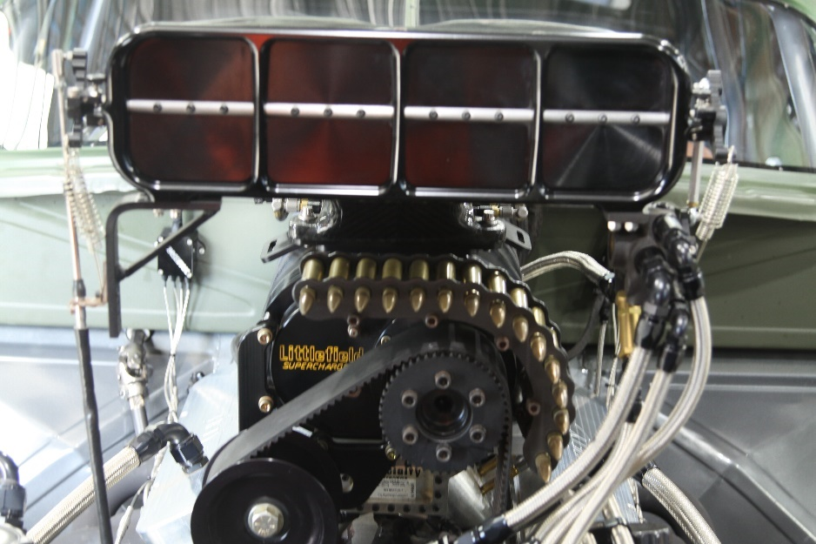

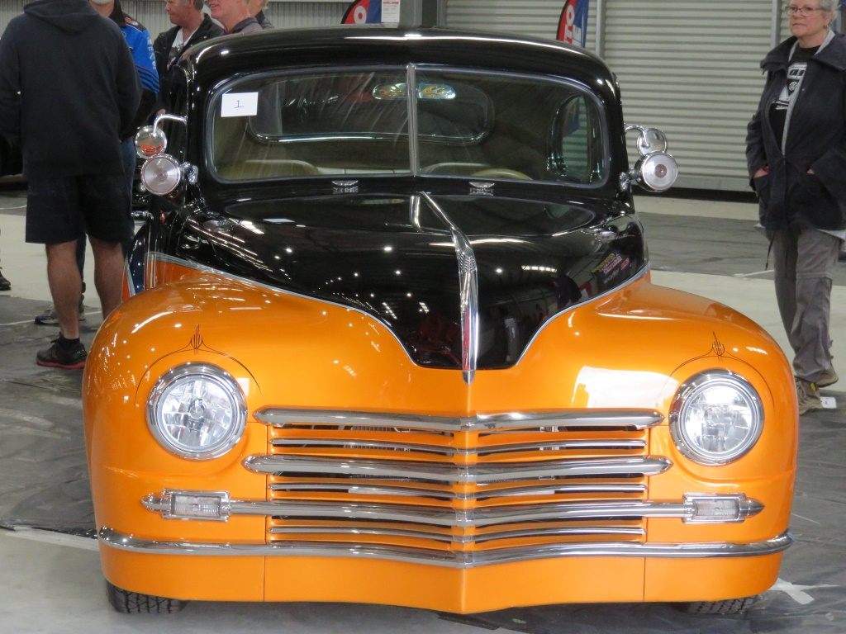

Why Sponsor GSSMA Inc.
Albany Show & Shine

Why Sponsor GSSMA Inc. Albany Show & Shine:

Sponsorship that goes beyond purely ‘awareness building’ to offer connection.
The GSSMA Inc. Albany Show & Shine celebrates everything that makes the motoring world so intoxicating. There isn’t a more potent marketing driver than emotion. When an emotional connection is made with customers, they are more likely to become loyal purchasers and brand advocates.
Sponsoring the GSSMA Inc. Albany Show & Shine is an opportunity for your brand to align itself with the excitement and passion of the motoring world. Your participation in this event provides your company with the opportunity to demonstrate your commitment to giving back to the community with a very reputable non-profit organization in which you will Gain market exposure.

- Brand visibility: Your brand will be prominently displayed throughout the Event, providing maximum exposure to attendees. This exposure can help to increase brand recognition, drive traffic to your business, and generate leads.
- Networking: You will have the chance to network and connect with other industry professionals, experts, and enthusiasts, which can lead to new partnerships, collaborations, and business opportunities.
- Activations and Activities: How you market yourselves at the event is only limited by your creativity –because we’re open to almost anything!
- Your Product in Action: Do you have a product or service aligned with the Event? This is the perfect platform to demonstrate it in action! Experiencing your products firsthand can increase customer loyalty, word-of-mouth marketing, and positive brand associations. After all, we know everyone loves a free sample or merch.

Your investment will not only help us to create a fantastic event but also provide you with an opportunity to increase your brand visibility, connect with other industry professionals, and showcase your latest products to a highly engaged audience.

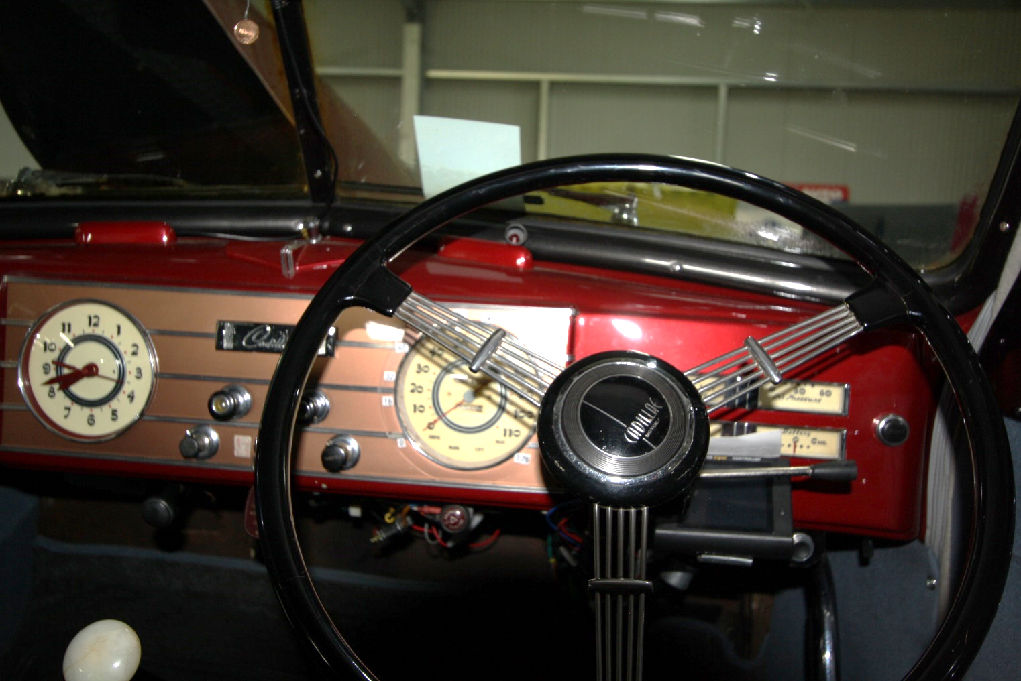

Sponsorship Packages

Sponsorship Packages:

The Great Southern Street Machine Association Inc invites you to participate in the 2025 GSSMA Triple M Albany Show & Shine as we raise funds to hold this event.
We have constructed five levels of sponsor packages on offer, with benefits to suit our partners, package benefits are flexible.
Our team is happy to work with you to tailor offerings and benefits to fit your unique marketing needs.
To register your interest and secure a spot, contact Event Coordinator on 0477 562572 or email gssma@hotmail.com

Package level | Available | Price of Level
Naming Rights | 1 | $15,000
Gold | 2 | $ 3,000
Silver | 4 | $ 1,500
Bronze | 8 | $ 500
Promotion | 6 | $ 250
Event Supplier | 2 | $ 5,000 Contra

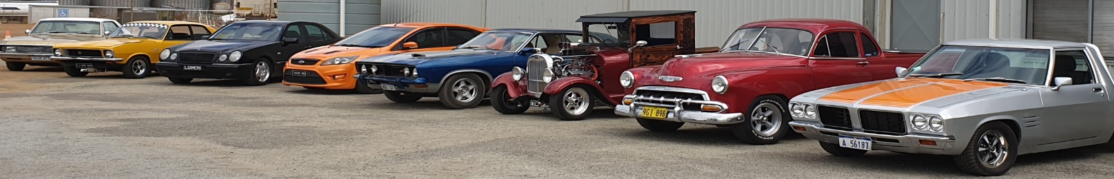

Sponsorship Benefits

Sponsorship Benefits:

No matter what the package is, all our sponsors are able to enjoy the following benefits:
- Sponsorship announced via GSSMA Inc. social media.
- All Sponsorship levels provides the opportunity to interact with our participants through our website, social media, email campaigns.
- Exclusive rights of association an event sponsor.
As well as the immediate sponsorship benefits, your package will have inclusions from the range below to put you on the fast track to building brand recognition, strengthening stakeholder relationships, and connecting with a whole new customer base.
- Cars & Cocktails, sample the James Bond life with cocktails amongst fine cars.
- Signage, your brand will be prominently displayed at the event, providing maximum exposure to attendees.
- the opportunity to provide products samples and/or place your marketing materials at the event.
- the opportunity to provide a display at the event for additional brand exposure (to be provided by you)
- Digital, our audience relies on our digital channels as a primary source of event information.
Specific sponsorship details you will receive are as followed:
Gold Package

- 1 x trophy, categories selected by the event administrators.
- Guest speaking opportunities for the Trophy Presentation
- Business logo on poster as a gold member
- logo featured on official documents.
- Your name/ Logo with recognition featured on GSSMA’S social media posts, Webpage.
- Email banner of gold members on GSSMA email account (Will remain in place all year)
- Link to sponsor website from GSSMA’S website. Gold member blog on our website.
- Passenger ride (club member’s car) on Super cruise/Poker Run
- Your business logo featured on the event program and sponsorship board.
- Your business banner, signs, flags featured at event (to be provided by you)
- Trade display at the event, indoors (to be provided by you)
- Radio interview at the event
- Business mention on event commentary
- Guest speaker/ interview at cars and cocktails
- 4 x full registration vehicle entry
- 2 x Family Pass to Show & Shine
- Appreciation certificate.

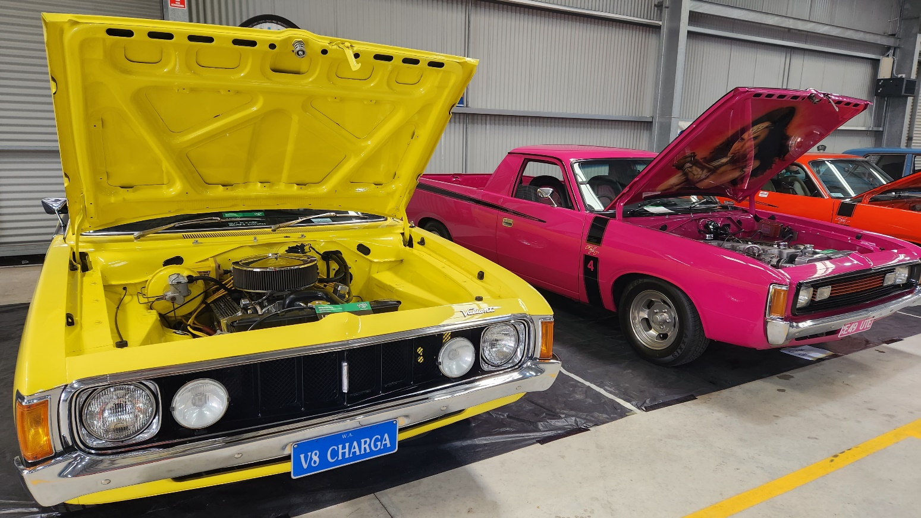

Silver package
- 1 x trophy, categories selected by the event administrators.
- Guest speaking opportunities for the Trophy Presentation
- Business logo on poster
- logo featured on official documents.
- Your name/ Logo with recognition featured on GSSMA’S social media posts, Webpage.
- Link to sponsor website from GSSMA’S website.
- Your business logo featured on the event program and sponsorship board.
- Your business banner, signs, flags featured at event (to be provided by you)
- Trade display at the event, 6x4 indoors (to be provided by you)
- Radio interview at the event
- Business mention on event commentary
- Interview at cars and cocktails
- 2 x full registration vehicle entry
- 2 x Family Pass to Show & Shine
- Appreciation certificate.
Bronze Package
- 1 x trophy, categories selected by the event administrators.
- Your name/ Logo with recognition featured on GSSMA’S social media posts, Webpage.
- Your business logo featured on the event program and sponsorship board.
- Your business banner, signs, flags featured at event (to be provided by you)
- Trade display, outdoors (to be provided by you)
- Business mention on event commentary
- Invitation to cars and cocktails
- 1 x full registration vehicle entry
- 1 x Family Pass to Show & Shine
- Appreciation certificate.
Promotion
- Your name/ Logo with recognition featured on GSSMA’S social media posts, Webpage.
- Your business logo featured on the event program and sponsorship board.
- Your business banner, signs, flags featured at event (to be provided by you)
- Invitation to cars and cocktails
- 1 x Family Pass to Show & Shine
- Appreciation certificate

Event Supplier
- 1 x trophy, categories selected by the event administrators.
- Your name/ Logo with recognition featured on GSSMA’S social media posts, Webpage.
- Your business logo featured on the event program and sponsorship board.
- Your business banner, signs, flags featured at event (to be provided by you)
- Business mention on event commentary
- Invitation to cars and cocktails
- 2 x Family Pass to Show & Shine
- Appreciation certificate.

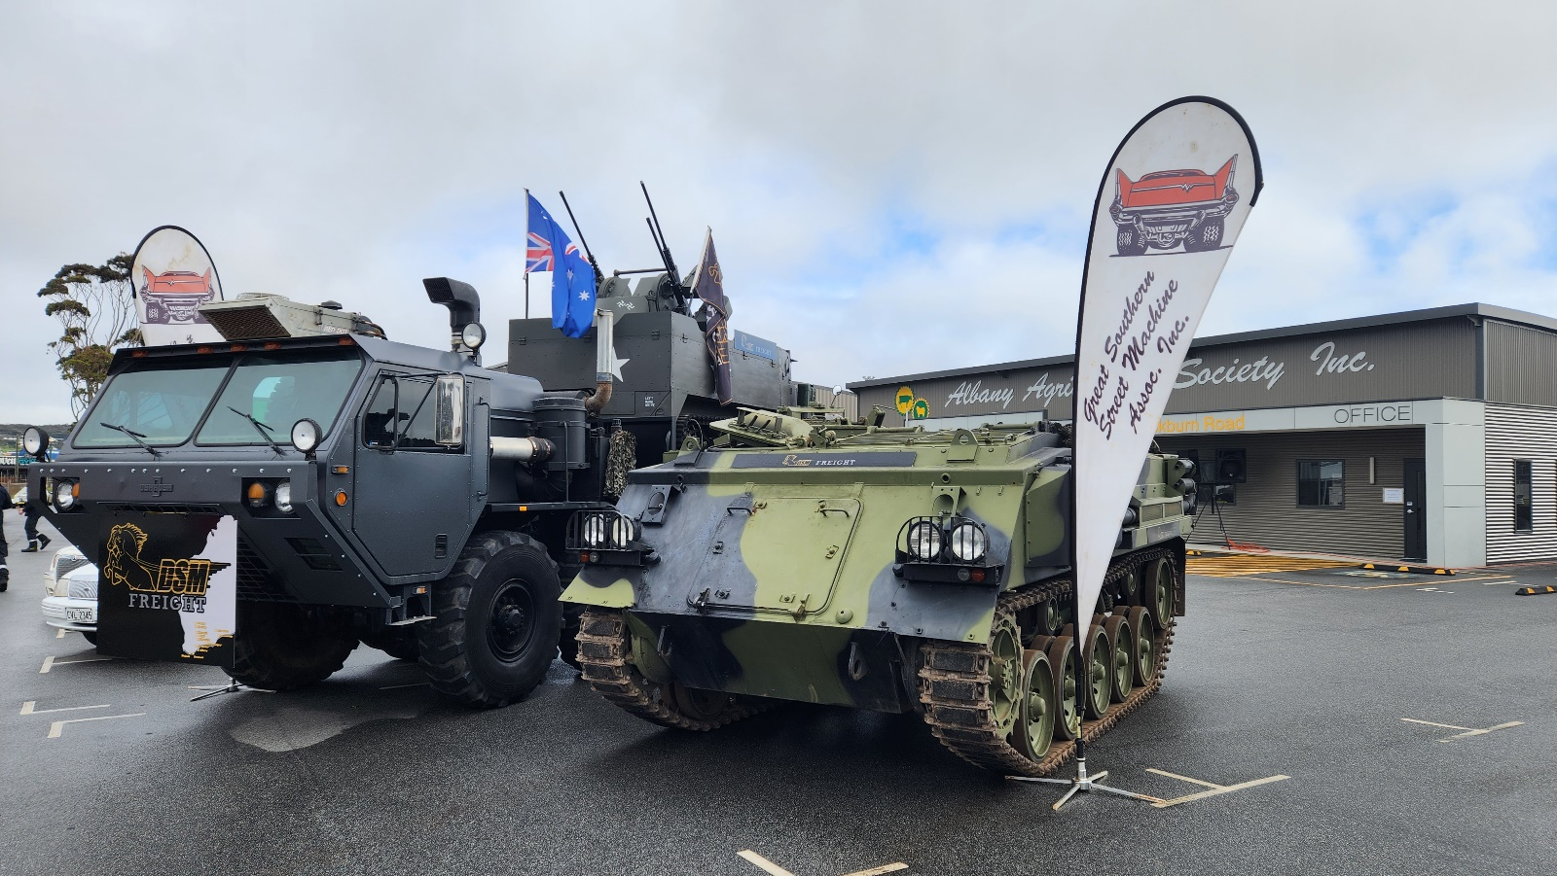

Show & Shine Sponsorship Confirmation 2025

Business Name: ____________________________________________________________
Contact Person: ____________________________________________________________
Mailing Address: ___________________________________________________________
Phone: Work: __________________________ Mobile: ____________________________
Email Address: _____________________________________________________________
Website Address: ___________________________________________________________
Facebook Address: __________________________________________________________
Package level | Available | Price of Level
Naming Rights | 1 | $15,000
Gold | 3 | $ 3,000
Silver | 4 | $ 1,500
Bronze | 8 | $ 500
Promotion | 6 | $ 250
Event Supplier | 2 | $ 5,000

Sponsorship Packages:

Naming Rights Gold Silver Bronze Promotion

Event Supplier

Payment options: Direct Deposit Cash

BSB: 086 518 Account No: 766524537 Narrative: Company/Business Name

Return this completed form to: GSSMA Inc. P.O. Box 2089, Albany 6331 or gssma@hotmail.com

Enquiries: 0477 562 572 or email gssma@hotmail.com

Signed: ______________________________________ Date: _______________________________

Thank you for your continued support!
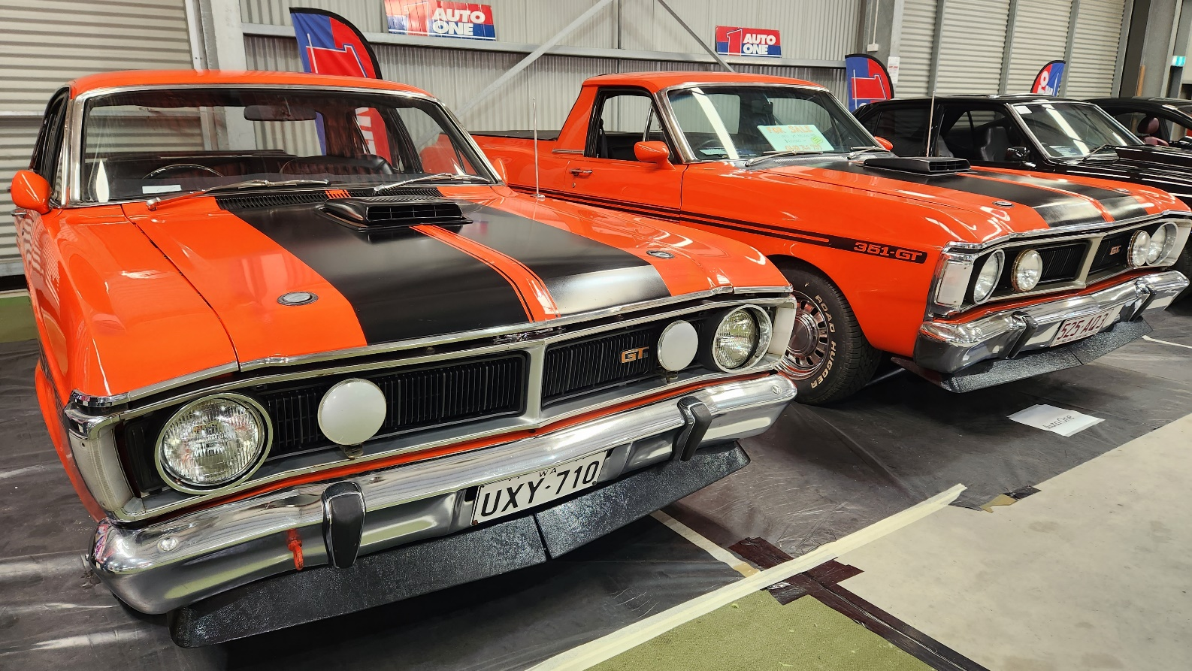

To help us please tick the boxes below:

YES NO
Authorisation to use company/business logo.

Signage, banner to use at Advertising events and on the day

Business cards/promotional material

Email/invoice banner (Proud Sponsor of: )

Trade Display

Representative for Trophy presentation

Passenger (club member’s car) Super Cruise /Poker Run

Car or Bike entrant (must fill out separate entry form or online)

Thank You!

Contact
Christine Sargent
Event Coordinator
0477 562572
gssma@hotmail.com

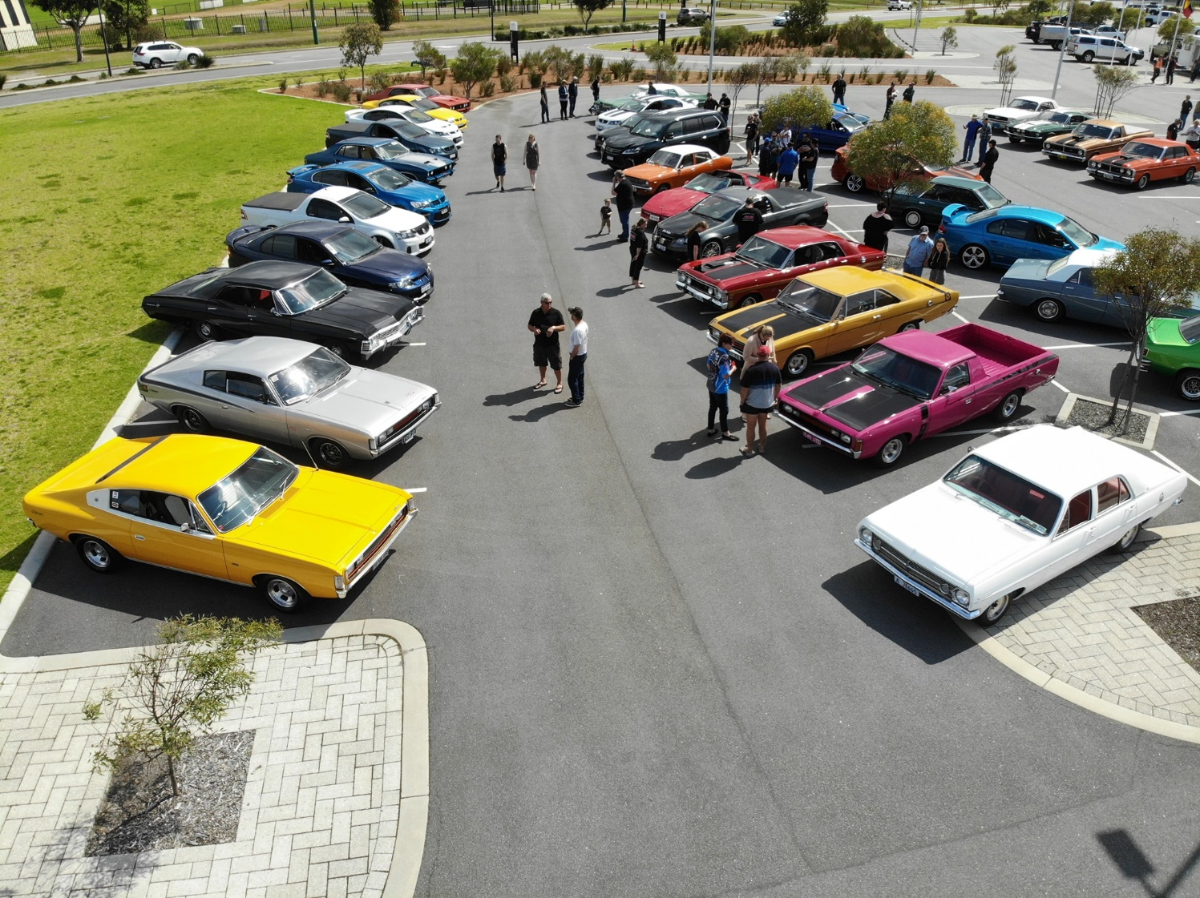

023 J

