

The Great Southern Street Machine Association will be staging a series of heats to establish the Rocker Cover Racer Champion at the Albany Show & Shine on Sunday the 22nd of September. Rocker cover racing entry is free and open for all ages of the public. One entry per person only. Trophy for the fastest rocker cover and the best looking.
28th Annual

Great Southern Street Machine Assoc.Inc

2024
Entry forms will be available online or at the rocker cover track on the day to fill out, you will also receive an entry number. Rocker cover racers will need to be entered between 10am-11am are to be on display and scrutineered with racing commencing at 1 pm, the entrant must be present for their car to run.
Please ensure you follow the rules:
- Cars shall be based on an actual rocker cover (valve cover) from a car engine. There shall be no limitation on engine make, model, cylinder configuration, or displacement.

- Cars must retain at least 75% of the original rocker cover and weight no more than 4 kg and must not have any form of mechanical propulsion or steering. Gravity is your friend.

- Cars must have 3 or 4 wheels, each no greater than 15 centimeters in diameter, with their overall length no more than 60cm and 30cm wide.

- Racing will run in heats of 2 cars each. The first car to have its front wheels cross the finish line at least 2 out of 3 times shall be declared the winner. If neither car makes it to the finish line the closest to finish will take the win. Winning cars will advance to the next round until all are eliminated - except one champion! (The Judges' decision is final)

- Entrants wishing to wear racing clothes, helmets, etc., do so at their own risk of being laughed at.

- Downforce wings, spoilers, air dams, etc. are all permitted.

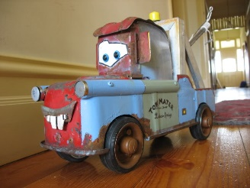
- Sponsorship logos, racing stickers and car names are all encouraged.
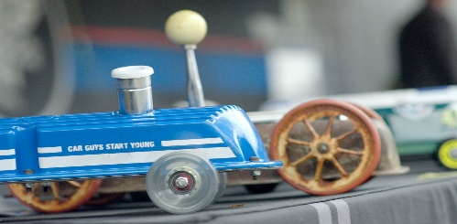

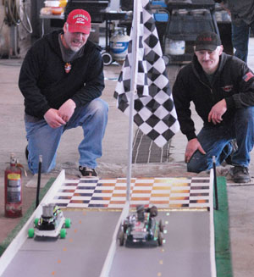
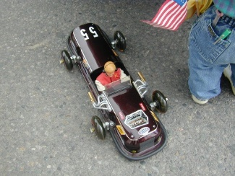
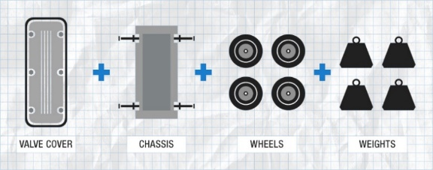

22nd September 2024 Rocker Cover Racer Entry Form
28th Annual

Great Southern Street Machine Assoc.Inc

2024

Entrants Name:

Address:

Phone: Mobile:

Email Address:
Brief description of your Rocker Cover Racer:

Office Use Only
Scrutineering:
Weight: …………………………………
Wheels: ...................................
Width; …………………………………...
Length: …………………………………...
Car Number: …………………………….

